RAMweb Electronic Payment Instructions

Log in to RAMweb at https://ramweb.colostate.edu/registrar/Public/Login.aspx
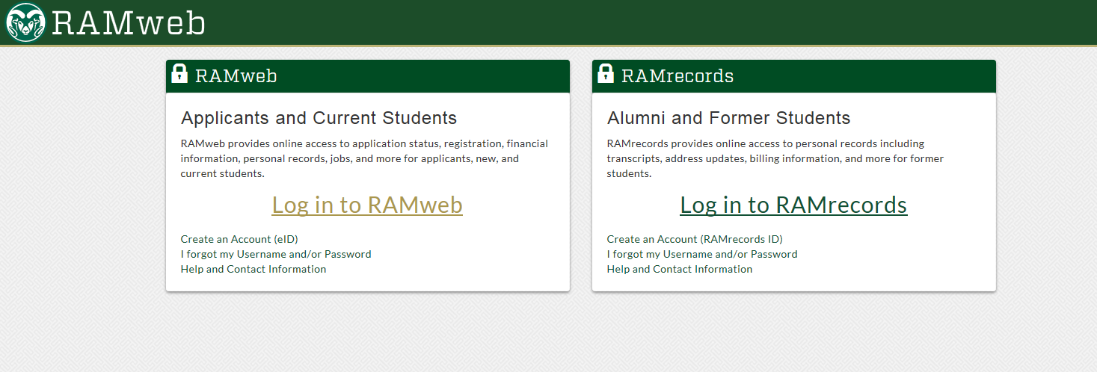

In the main Menu, select Billing and Tax Information
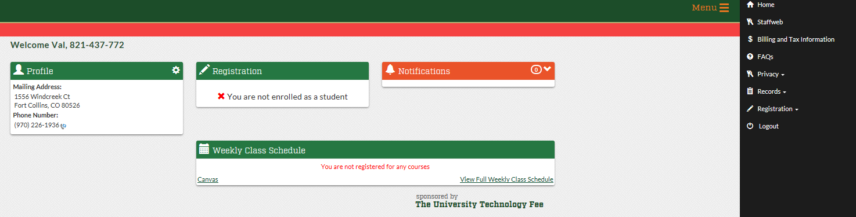

Select Pay My Bill
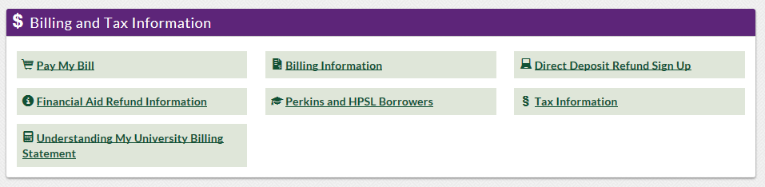

Enter amount you would like to pay and click Continue

Select your payment method from the options and click Continue Checkout
(Credit Card payments will be directed to our third party processor Colorado.gov)

Enter all requested information and click Submit
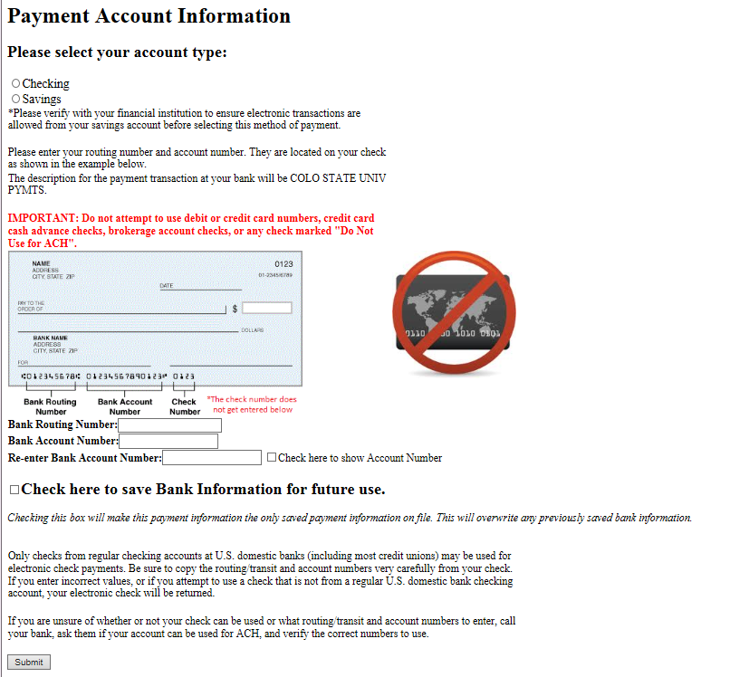

Verify payment and banking information and click Submit
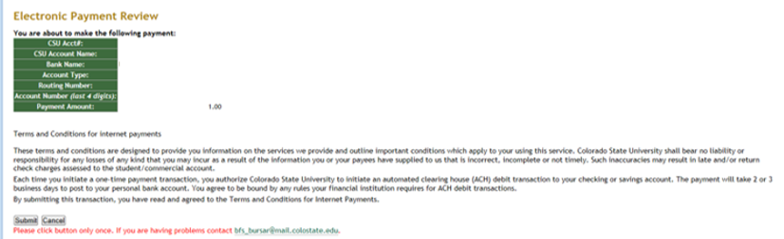

Your receipt number will be shown here and emailed to you

